**Sportive Health Routine Regulator**

**Prepared by : Essam Abosalem**

1. **Program Description**

This program is a system that manages a set of data of an admin, employees and members. The admin can add some employees under him. The employees can add new members to instruct. The member enters a set of required data and gets recommended an exercise routine according to his/her type and a Diet routine with items for the three meals of the day.

1. **Running Screenshots with description**

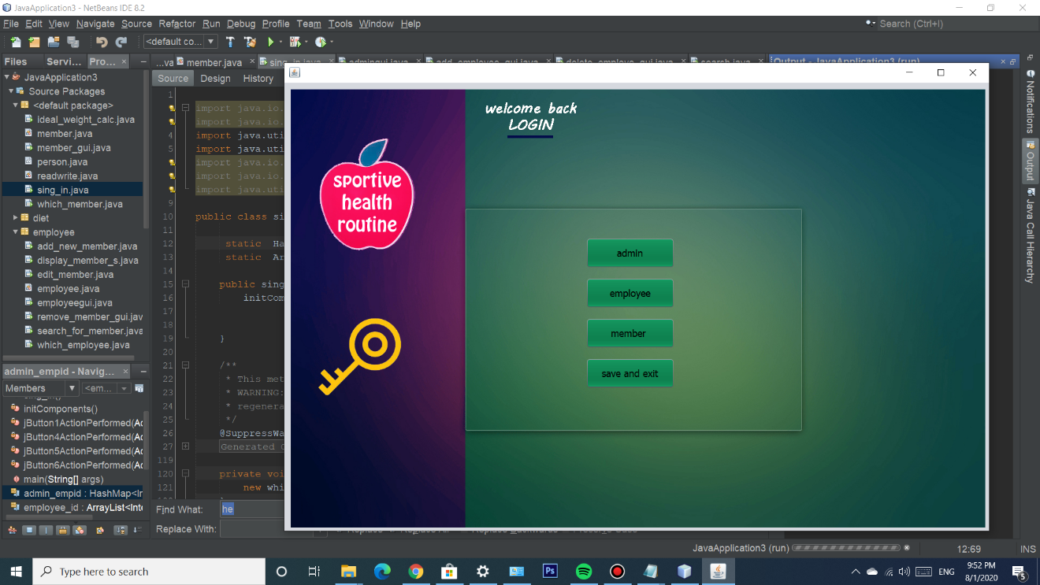

1. This is the main window of the Sportive health routine regulator program, the user chooses between admin, employee, member or he/she can save and exit the program.
2. **Admin Features**

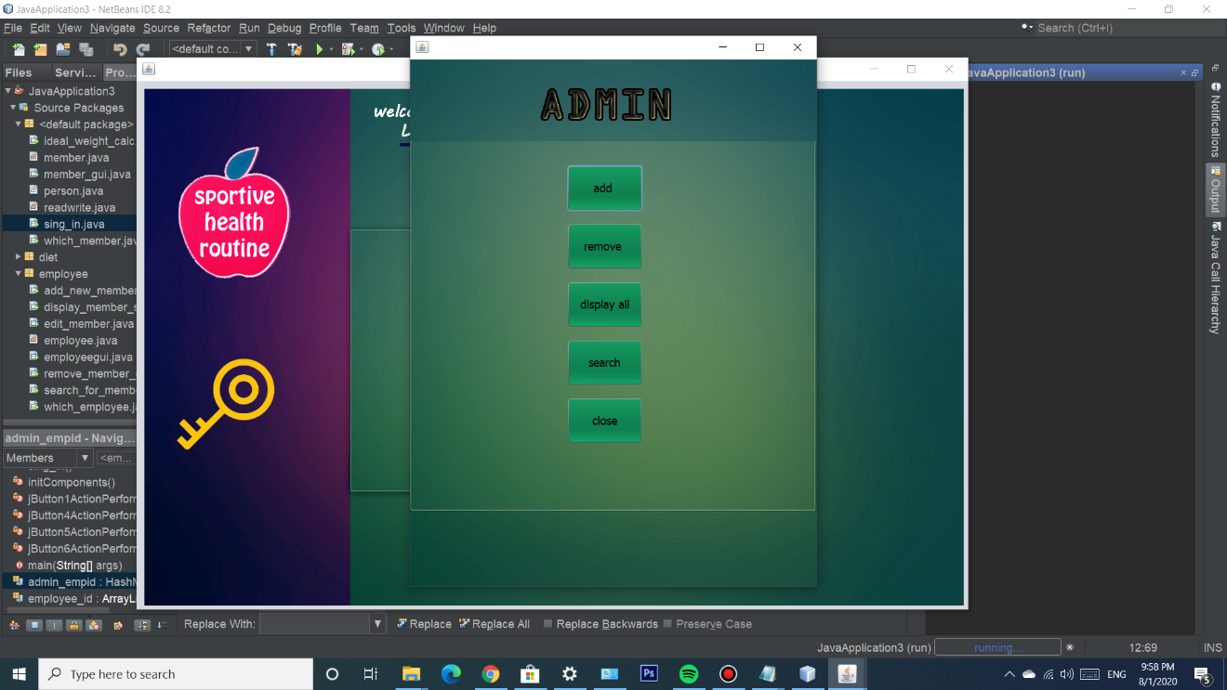

1. This is the admin window with all of the admin features where he can add an employee, remove an employee, display all of the employees currently saved or close to go back.

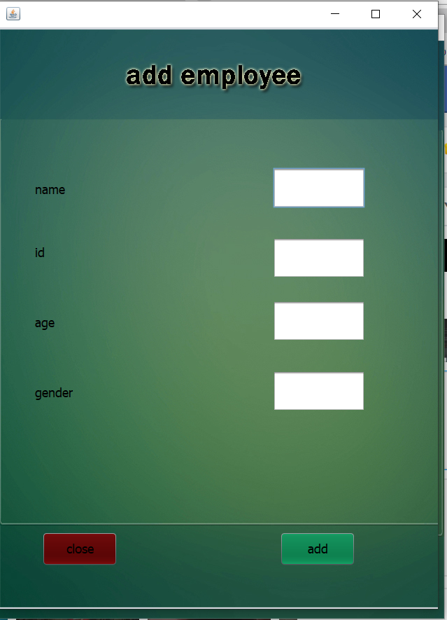

1. Admin window to add an employee.

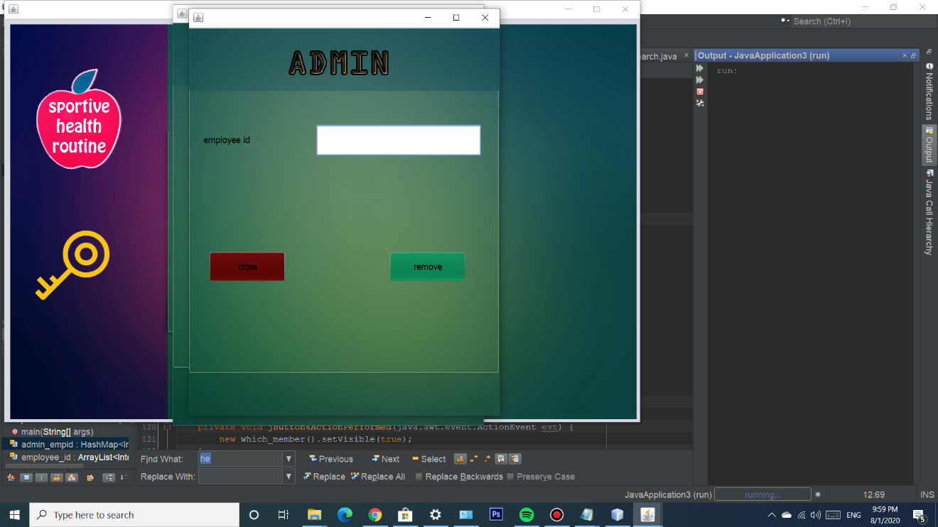

1. Admin window to remove an employee by entering his id.

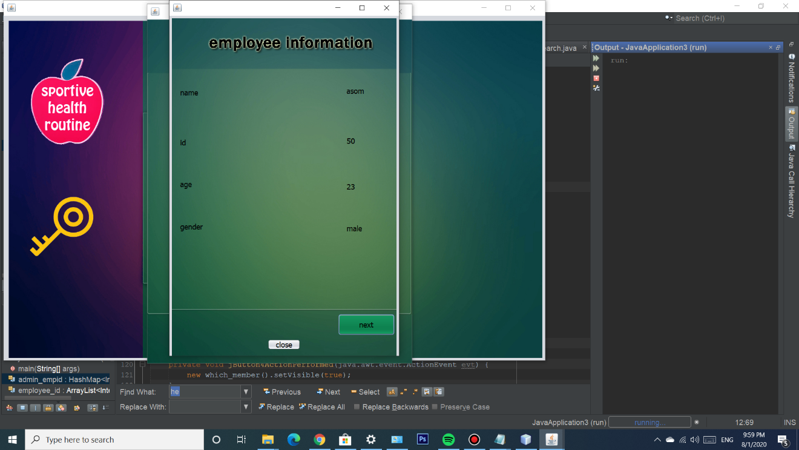

1. Admin window to display employee information.
2. **Employee Features**

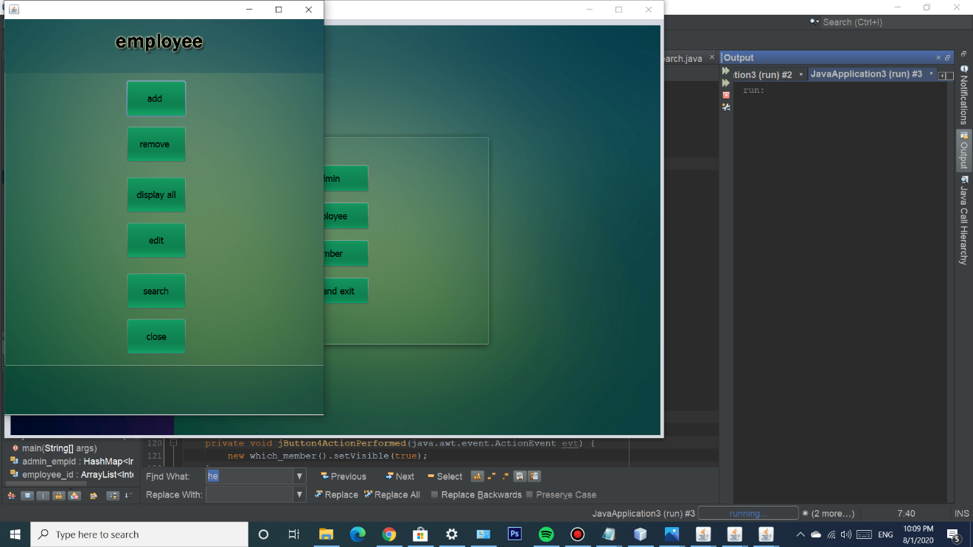

1. This is the Employee main window where the user can add a member, remove a member, display all of his assigned members, edit the information of any of his members, search for a specific member or go back to the main window.

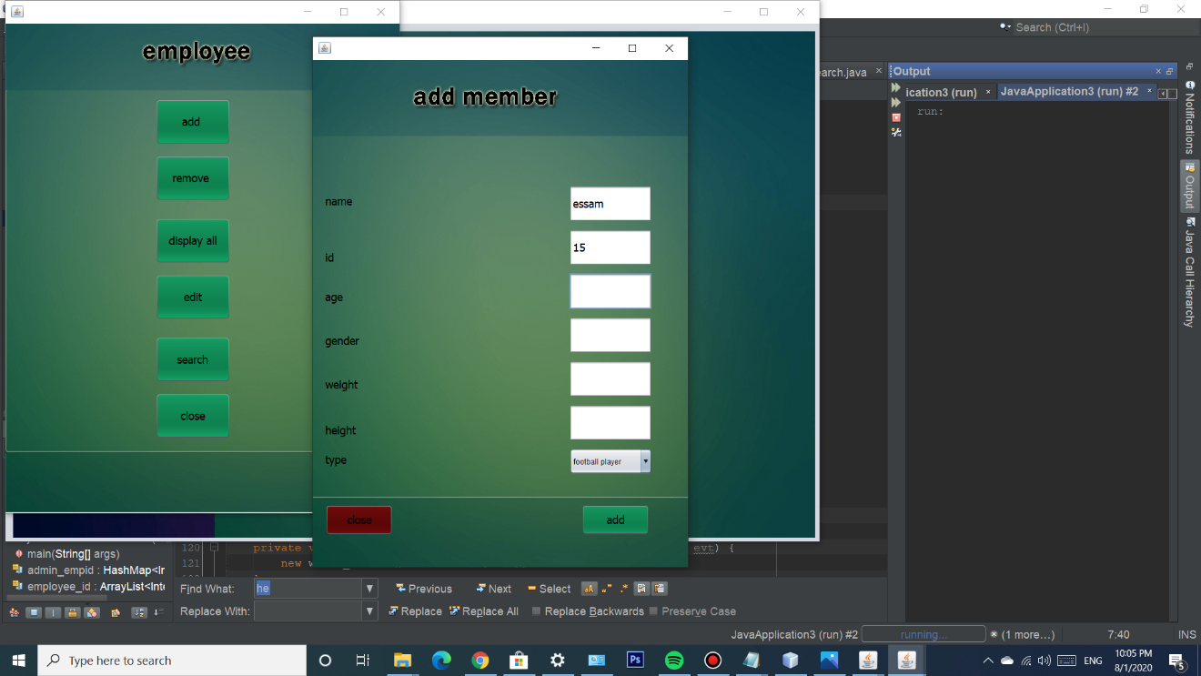

1. Employee window to add a member.

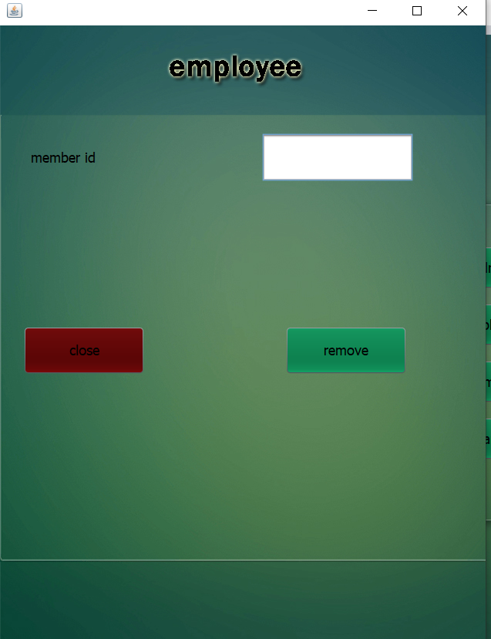

1. Employee window to remove a member by writing his id.

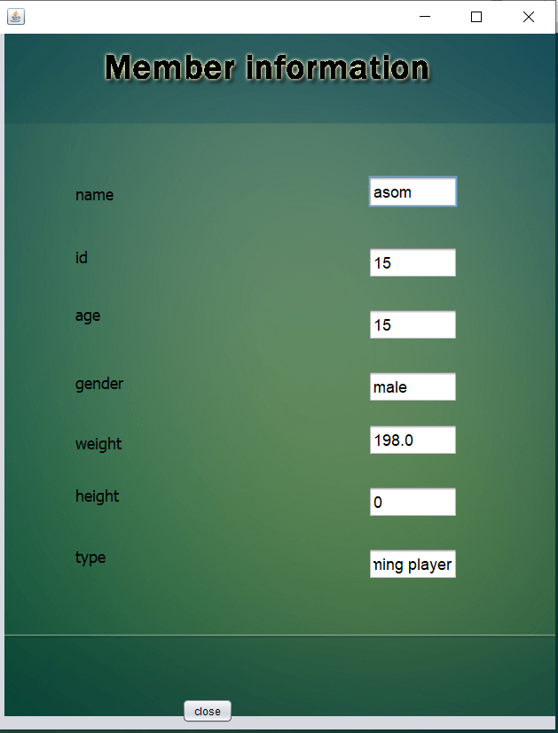

1. Employee window to display his/her members.

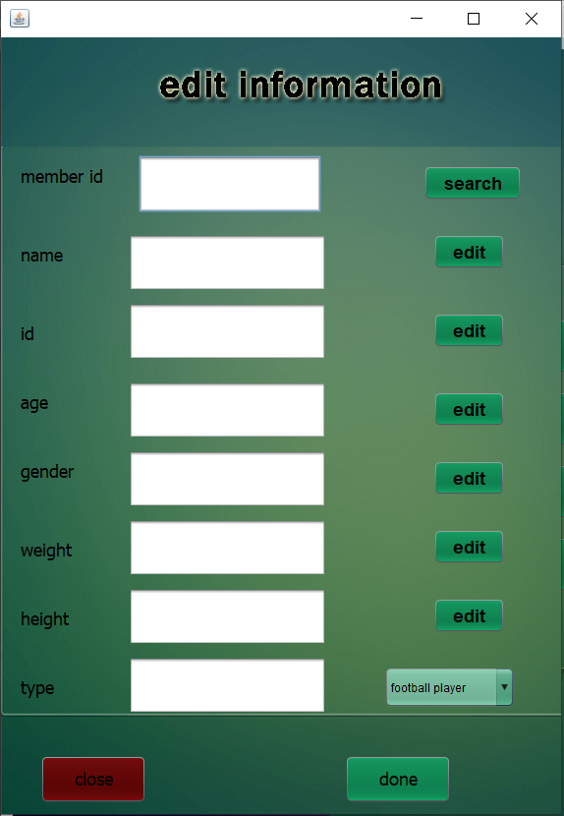

1. Employee window to edit his/her members’ information.

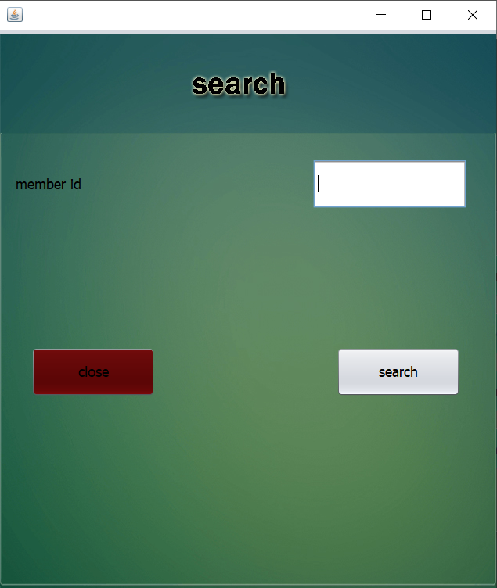

1. Employee window to search for his/her members by writing his id.
2. **Member Features**

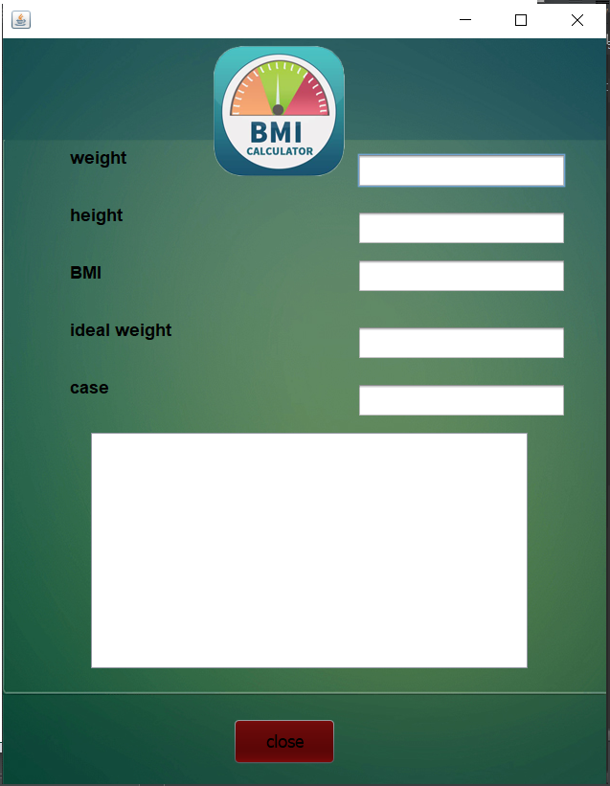

1. This is the main window of the member user.

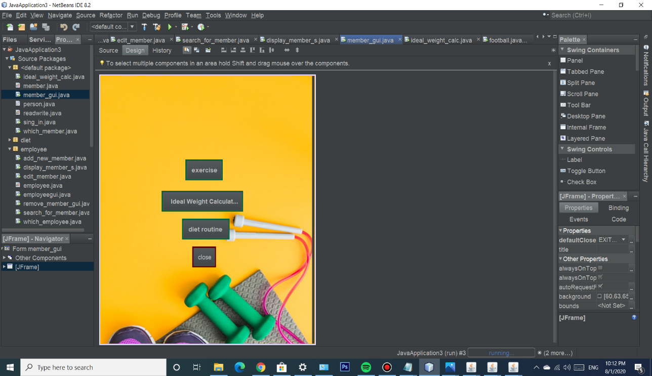

1. Secondary member main page.

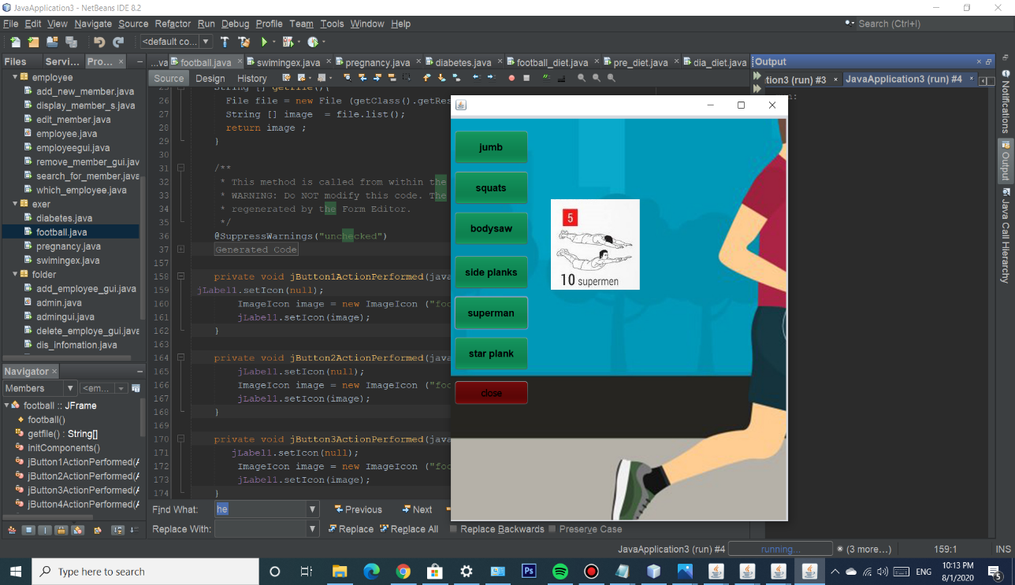

1. Swimmer’s main page.

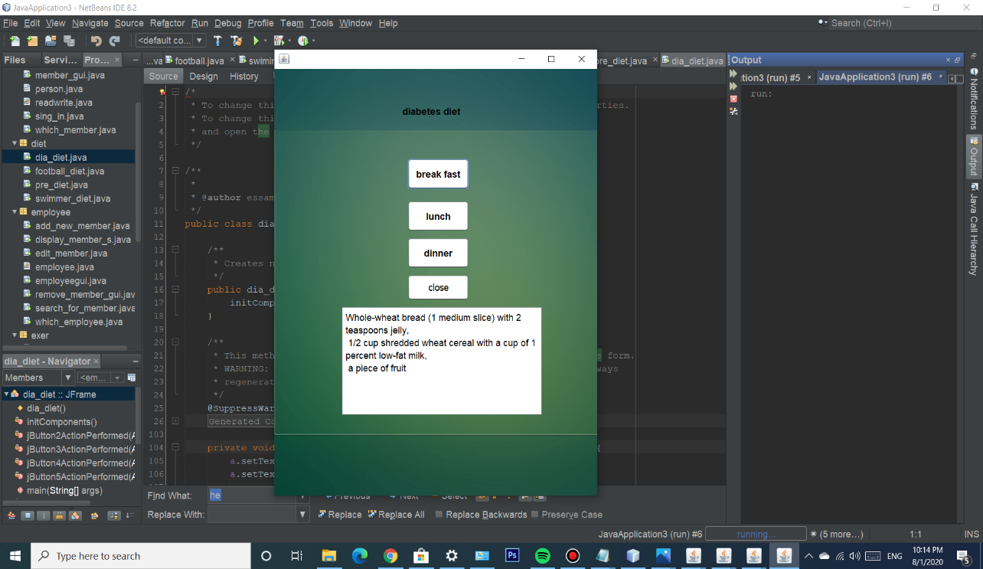

1. Diabetes member’s recommended diet.

**Prepared by : Essam Abosalem**